Haroutun Haroutunian

Professor Berhe

ECE 443L

8 February 2022

**Lab 1: Familiar with CMOS Transistors**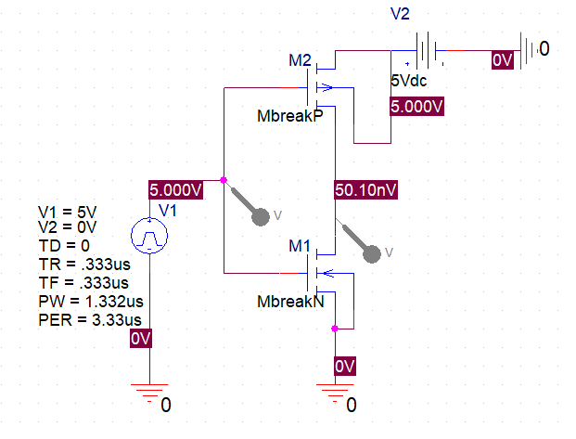

Figure 1.1: Case 2 CMOS Inverter circuit with square wave input of 5V @ f = 300 kHz

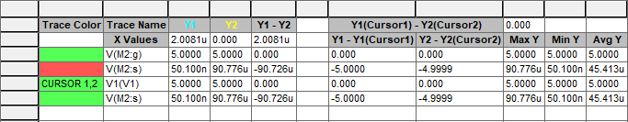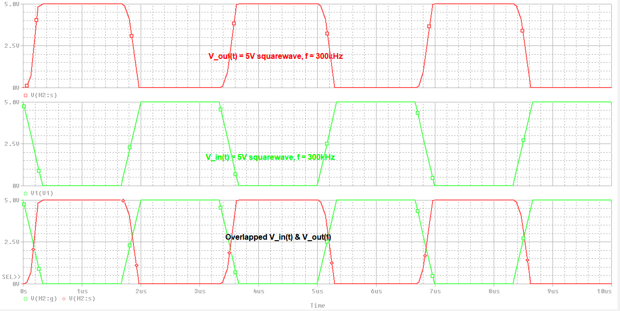

Figure 1.2: I/O waveforms of CMOS inverter with input of 5V @ f = 300kHz

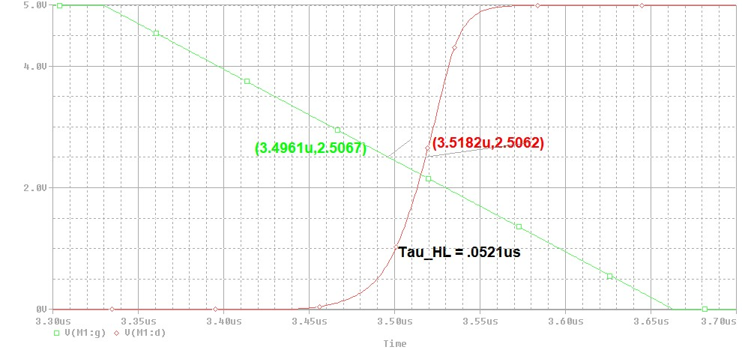

Figure 1.3: ZOOMED I/O waveforms of CMOS inverter of propagation delay High-to-Low @ f = 300kHz

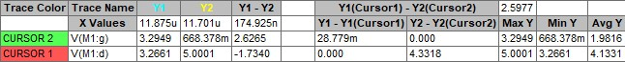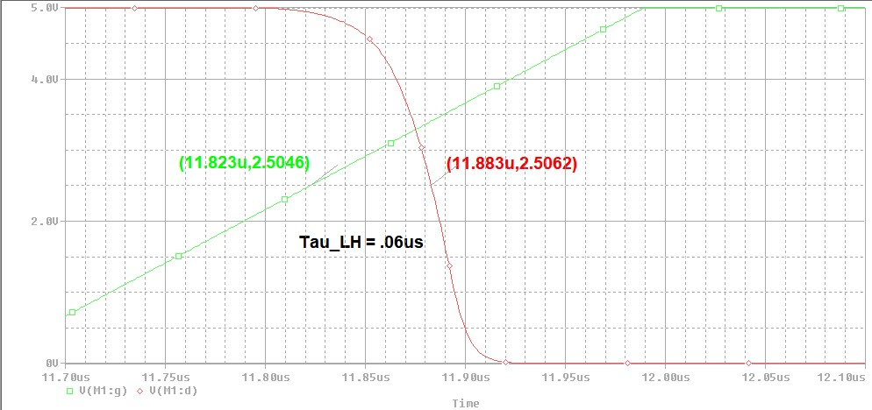

Figure 1.4: ZOOMED I/O waveforms of CMOS inverter of propagation delay Low-to-High @ f = 300kHz

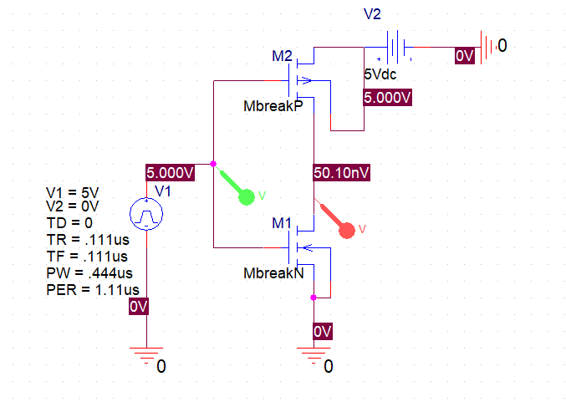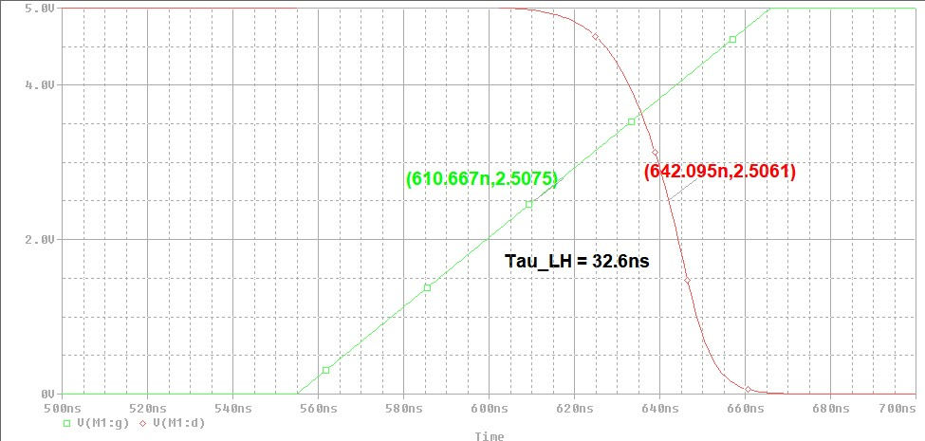

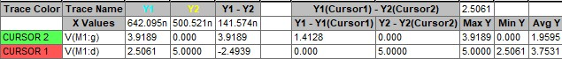

Figure 1.5: CMOS Inverter circuit with square wave input of 5V @ f = 900 kHz

Figure 1.6: I/O waveforms of CMOS inverter with input of 5V @ f = 900kHz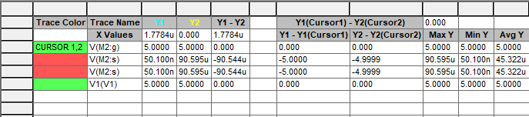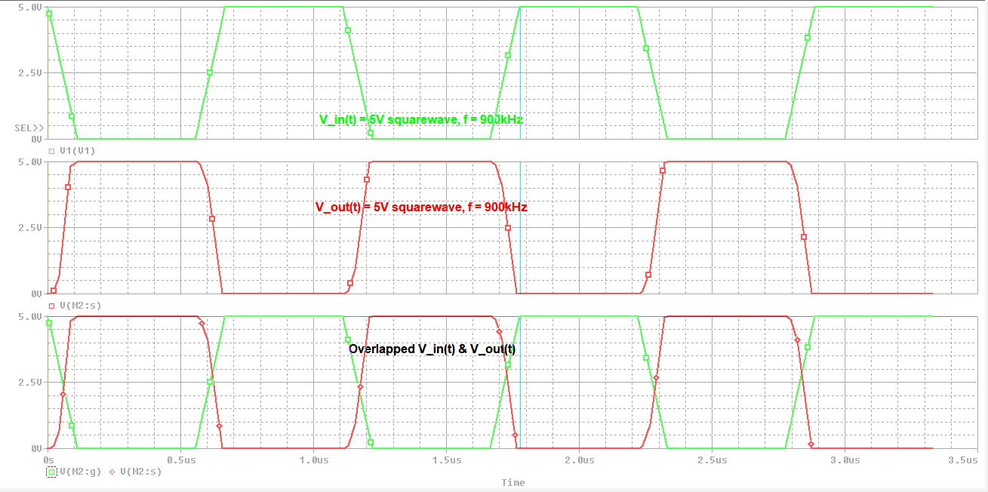

Figure 1.7: ZOOMED I/O waveforms of CMOS inverter of propagation delay Low-to-High @ f = 900kHz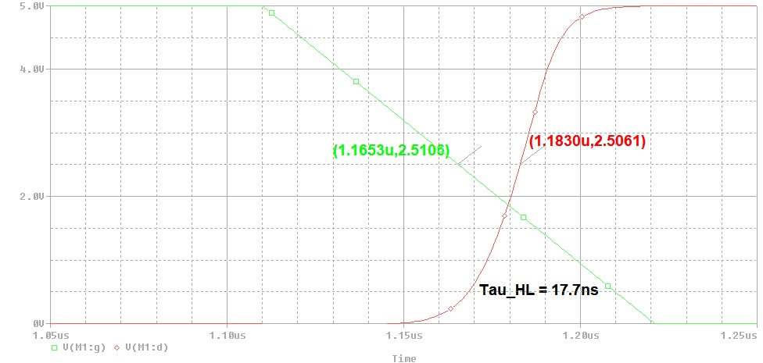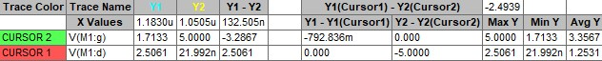

Figure 1.8: ZOOMED I/O waveforms of CMOS inverter of propagation delay Low-to-High @ f = 900kHz

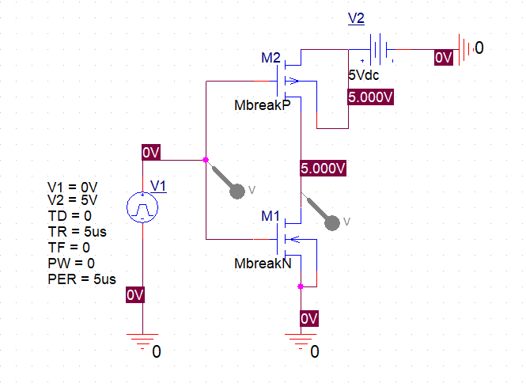

Figure 1.9: CMOS Inverter circuit with ramp wave input of 5V @ f = 200 kHz

Figure 1.10: I/O waveforms of CMOS inverter with input of 5V @ f = 200kHz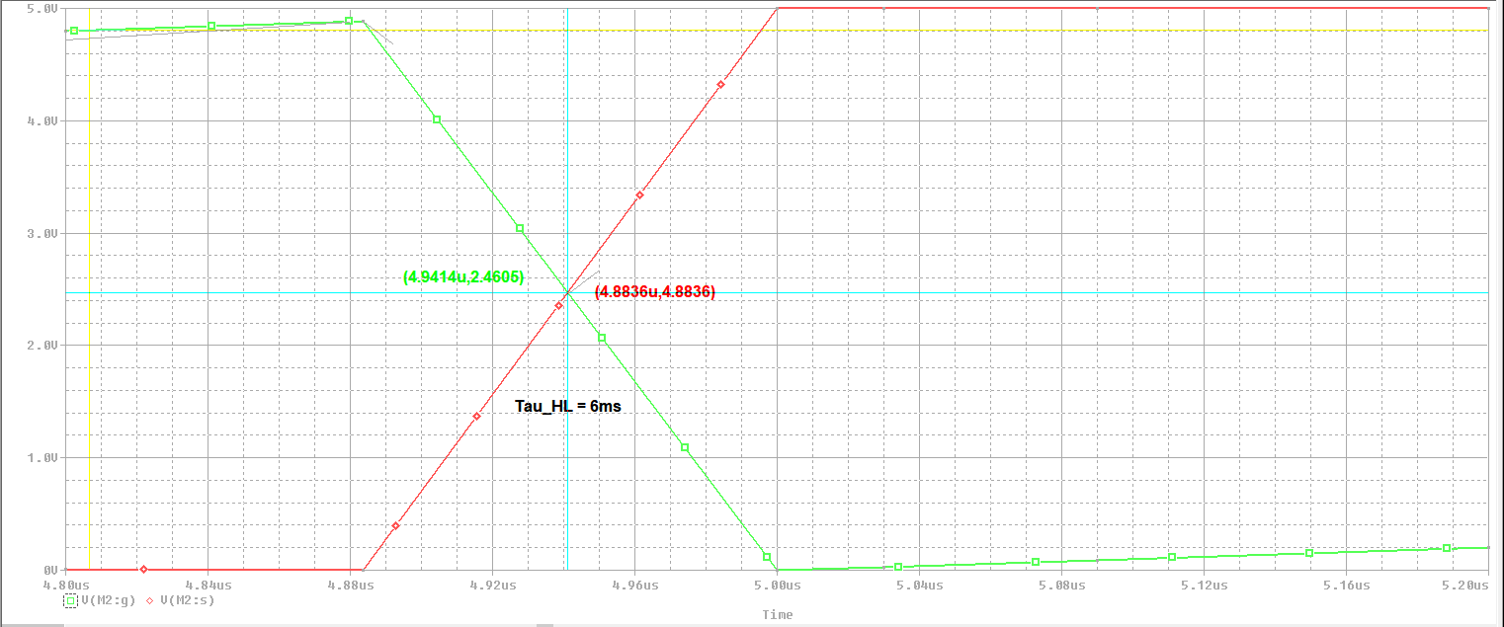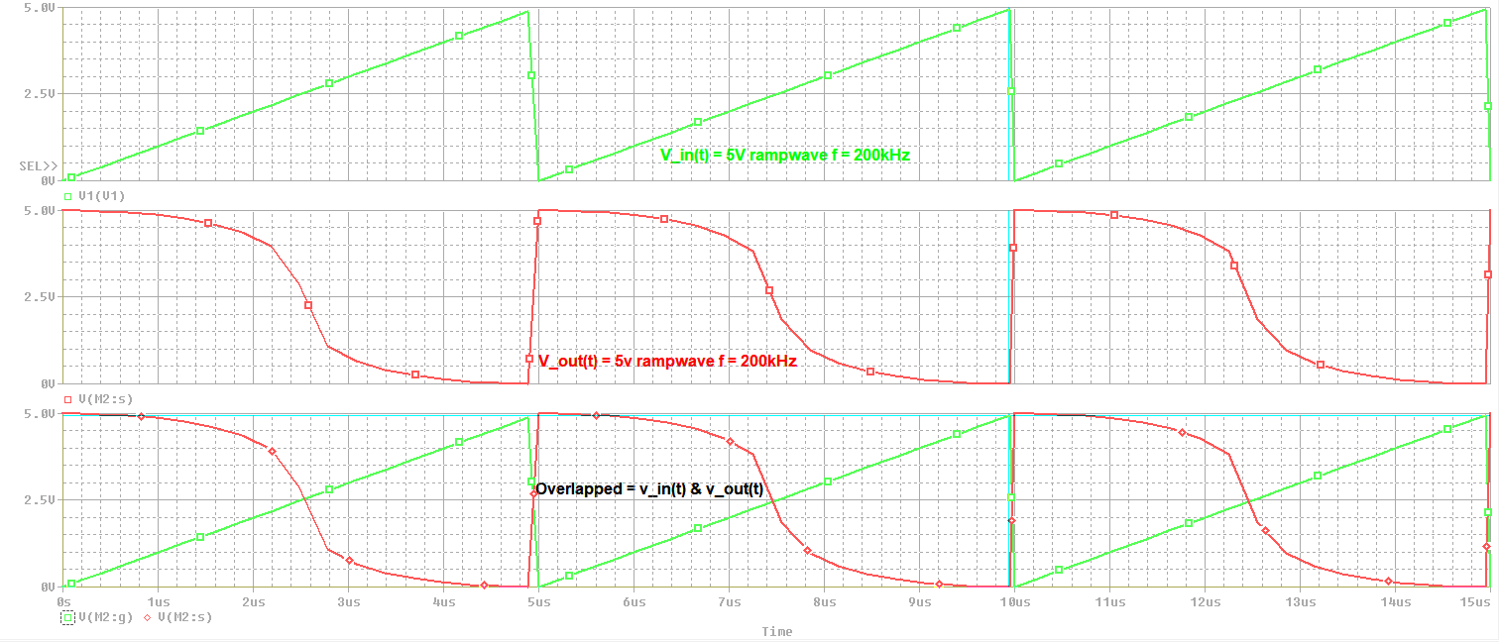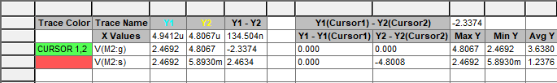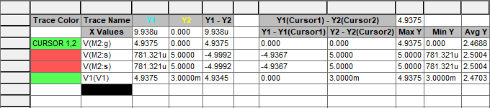

Figure 1.11: ZOOMED I/O waveforms of CMOS inverter of propagation delay Low-to-High @ f = 200kHz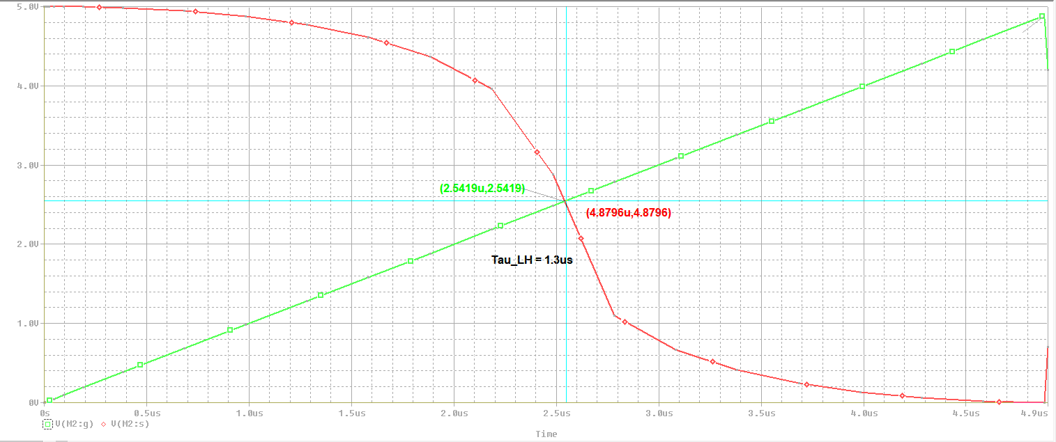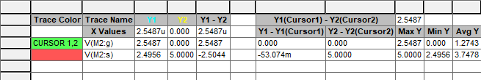

Figure 1.12: ZOOMED I/O waveforms of CMOS inverter of propagation delay High-to-Low @ f = 200kHz